NADAR SARASWATHI COLLEGE OF ENGINEERING AND TECHNOLOGY, THENI-625531

**APROJECTSTAGEIREPORTON**

**”DRUGTRACEABILITYINHEALTHCAREUSINGBLOCKCHAIN”**

**In partial fulfillment for the award of the degree**

**Of**

**BACHELOR OF ENGINEERING**

**IN**

**COMPUTER SCIENCE AND ENGINEERING**

**Submitted by**

**P.AKSHAYA (921020104004)**

**M.ILAKKIYA (921020104021)**

**P.SATHYAPRIYA (921020104046)**

**V.R.SHRUTHI (921020104049)**

**UNDER THE GUIDANCE OF**

**MR.VELKUMAR,AP/CSE**

1. **INTRODUCTION**

In today's business landscape, toll-free phone numbers play a crucial role in connecting organizations with their customers, providing a cost-effective means of communication. Transparent toll-free data management is an essential initiative designed to streamline the collection, storage, analysis, and utilization of data related to toll-free numbers while upholding principles of transparency and compliance with data privacy regulations. This practice is vital for businesses and organizations seeking to enhance their customer service, marketing efforts, and overall operational efficiency. A transparent toll-free data management project refers to an initiative aimed at effectively and openly managing data related to toll-free phone numbers. Toll-free numbers are telephone numbers that allow callers to reach a business or organization without incurring any call charges. They are often used for customer support, information hotlines, and marketing purposes. Managing the data associated with these toll-free numbers is essential for ensuring smooth operations, tracking performance, and maintaining transparency in the process. The primary purpose is to efficiently manage and organize data related to toll-free phone numbers. Objectives may include improving customer service, optimizing marketing efforts, and ensuring compliance with regulations. Gather data associated with toll-free numbers. This includes information such as the number itself, the organization it belongs to, usage statistics, and customer feedback. Establish a secure database or data management system to store toll-free number data. Implement security measures to protect sensitive customer information. Utilize data analytics tools and techniques to extract valuable insights from the collected data. Analyze call patterns, customer interactions, and service quality. Implement mechanisms to ensure transparency in data management, such as making certain data accessible to the public or relevant stakeholders. Clearly define who has access to the data and for what purposes.

* 1. **PROJECT OVERVIEW**

The primary objective of this project is to establish a transparent and efficient system for managing toll-free telephone numbers and the associated data. This system should ensure data security, privacy, and accessibility while promoting accountability and integrity in the management of toll-free numbers.

* Data Collection and Registratio
* Public Access Portal
* Data Security

2.1 EXISTING PROBLEM

Existing System In today's world, The data businesses collect and manage (and, in many cases, sell) is personal and important to their customers. This is a truth businesses need to acknowledge—your customers care about their data more than your marketing, violate their trust and there isn’t an HTML email, sale, or event you can launch that will fix it.

To customers, it goes beyond marketing communications or personalization. It’s their identity. And they’ve seen too many cautionary tales to not take it seriously. The opportunity wrapped up in transparent data management is that you can build trust with your customers

2.2 REFERENCES

* Allen Francis Antony, Anju P, Gautham Raj P, Keerthana M. S, Divya M. Menon, “Design of an Integrated Speed Tracking and Toll Management System for Express Highways,” IEEE 2017 International Conference on Computing Methodologies and Communication (ICCMC), Erode, India, 2017, pp. 1-4
* R. Shankar and A. V. Singh, "Use of VANETs for human Safety in road transportation," 2015 4th International Conference on Reliability, Infocom Technologies and Optimization (ICRITO) (Trends and Future Directions), Noida, India, 2015, pp. 1-6
* S. Babu and B. S. Manoj, "On the topology of Indian and Western road networks," 2016 8th International Conference on Communication Systems and Networks (COMSNETS), Bangalore, 2016, pp. 1-6. doi: 10.1109/COMSNETS .2016
* M. Gorajanal, P. Mannikeri, V. Nayak, V. Deshpande and M. Bhille, "AUTO-FIR - Automobile's first information record," 2015 IEEE International Advance Computing Conference (IACC), Banglore, 2015, pp. 1128-1133S.Delgado-Segura,C.P´erez-Sol`a,G.Navarro-Arribas,andJ.HerreraJoancomart´ı, “Analysis of the bitcoin UTXO set,” in Financial Cryptography and Data Security(LectureNotesinComputerScience),vol.10958,A.Zohar,Ed.Berlin,Germany:Springer,2019,pp.7891.
* J. Huang, X. Li, Y. Sun and Q. Xu, "A highly-reliable combined positioning method for vehicle in urban complex environments," Proceedings of 2013 IEEE International Conference on Vehicular Electronics and Safety, Dongguan, 2013, pp. 153-158.
* P. Khanzode, S. Nigam, S. P. Karthikeyan, K. S. Kumar and I. J. Raglend, "Indian power scenario-a road map to 2020," 2014 International Conference on Circuits, Power and Computing Technologies ,2014.
* B. T. N. Diogo C. Luvizon and R. Minetto, “Vehicle speed estimation by license plate detection and tracking,” IEEE International Conference on Acoustic, Speech and Signal Processing (ICASSP), 2014.
* V. K. Madasu and M. Hanmandlu, “Estimation of vehicle speed by motion tracking on image sequences,” IEEE Intelligent Vehicles Symposium University of California, San Diego, CA, USA June 21- 24, 2010, June 21-24, 2010.
* Myung-Soon CHANG, Kyung-Woo KANG, Young-Tae OH and Hee-Woon JUNG, “Evaluations and Improvements of The Korean Highway Electronic Toll System,” 2002, IATSS Research, 2002
* Itsuro Otaki, Yoshikazu Imanishi, Kosuke Miyatake, Toshinori Nemoto and Naohiro Uchiyama, “Effects of the change of toll system on social surplus: A case study of distance-based toll in Tokyo Metropolitan Expressway,” 2017, World Conference on Transport Research Society, 2017
* Issam Damaj and Rached Zantout, “GPS-based Vehicle Tracking System-on-Chip”, International Journal of Electrical & Computer Sciences
* P.J. Pe´rez-Martı´nez, D. Ming, G. Dell’Asin, A. Monzo´n, “Evaluation of the influence of toll systems on energy consumption and CO2 emissions: A case study of a Spanish highway”, 2010, TRANSyT, Universidad Polite´cnica de Madrid, Profesor Aranguren, 28040 Madrid, Spain

2.3 PROBLEM STATEMENT DEFINITION

Toll-free numbers are a valuable resource for businesses and organizations to provide a convenient way for customers and stakeholders to contact them without incurring any calling charges. However, the management of toll-free data, including call records, routing information, and cost analysis, can be complex and often lacks transparency. This can lead to operational inefficiencies, increased costs, and difficulties in tracking and improving customer interactions. The problem at hand is the need for an efficient and transparent toll-free data management system. Toll-free data is often scattered across various departments and systems, making it challenging to have a unified view of customer interactions. This lack of centralized data can hinder decision-making and analysis. Toll-free numbers may not be routed optimally, leading to misdirected calls, longer wait times, and decreased customer satisfaction. Inefficient routing can also result in unnecessary expenses. Managing the costs associated with toll-free numbers can be challenging. Organizations need a clear breakdown of expenses, including call costs, subscription fees, and service provider charges, to optimize spending.

3.IDEATION & PROPOSED SOLUTION

3.1 EMPATHY MAP CANVAS

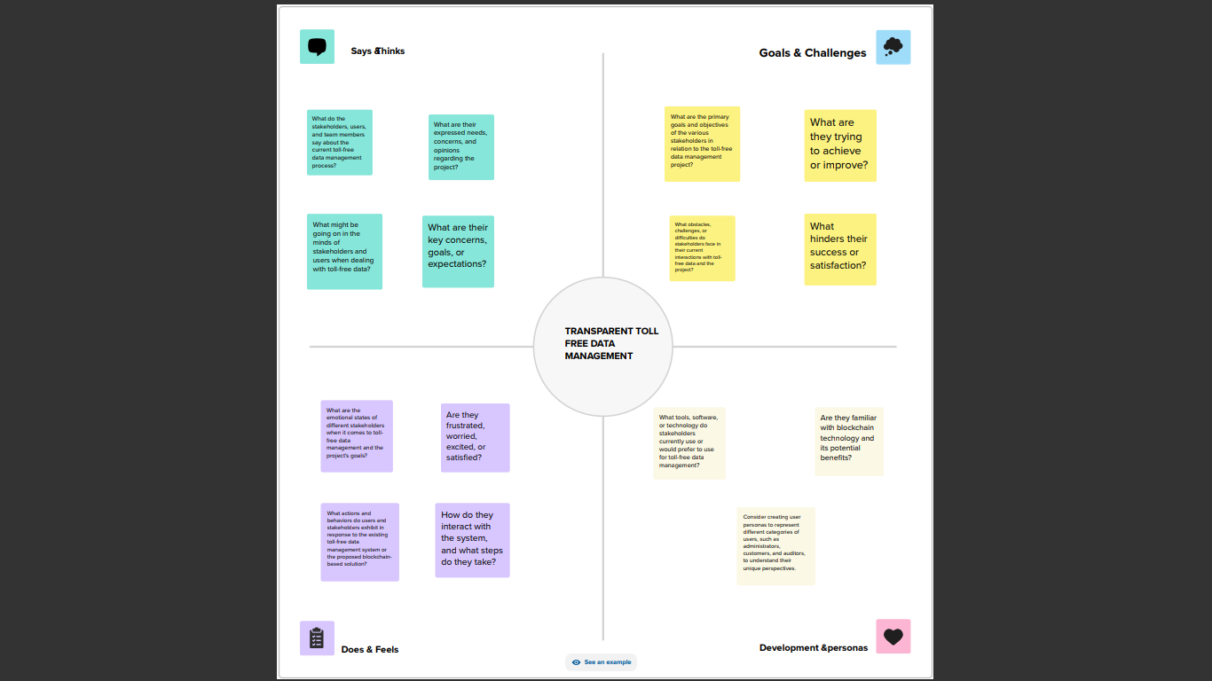

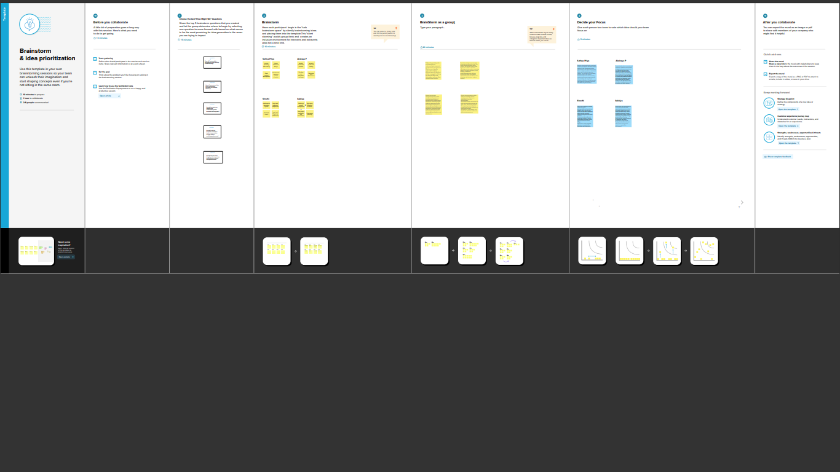

IDEATION PHASE & BRAINSTORM

The ideation phase of transparent toll-free data management, you should focus on generating creative ideas and strategies to ensure that data related to toll-free numbers is managed in a transparent and compliant manner. Here are some steps and considerations for this phase:

**Identify Goals and Objectives**: Define clear goals for transparent toll-free data management. What are you trying to achieve with this initiative? This could include data security, compliance with regulations, and improved customer service.

**Understand Data Sources:** Identify the sources of data related to toll-free numbers. This might include call logs, customer information, and usage data.

**Data Classification:** Categorize the data you're dealing with. Some data may be more sensitive than others, and this will impact how it should be managed transparently.

**Compliance Requirements:** Research and understand the legal and regulatory requirements related to toll-free number data management. This could include data protection laws, industry standards, and regional regulations**.**

**Data Inventory:** Create an inventory of all data related to toll-free numbers. This includes where it's stored, who has access, and how it's used.

**Transparency Strategy:** Develop a strategy for how transparency will be achieved. This might involve data access controls, data sharing policies, and communication with stakeholders.

**Privacy Impact Assessment:** Conduct a privacy impact assessment to identify potential risks and areas where transparency is critical. This can help in the development of mitigation strategies.

**Data Governance Framework:** Establish a data governance framework that outlines roles and responsibilities for data management. This framework should include data stewards, data custodians, and data owners.

**Technological Solutions:** Consider what technological solutions can be employed to ensure transparency. This could involve data encryption, access controls, and auditing tools.

**Employee Training:** Provide training to employees who handle toll-free number data to ensure they understand the importance of transparency and compliance.

**Monitoring and Auditing:** Implement a system for monitoring data management practices and conducting regular audits to ensure compliance.

**Data Retention and Disposal:** Define policies for data retention and disposal. Data that is no longer needed should be securely disposed of to maintain transparency.

**Communication Plan:** Develop a communication plan for stakeholders, including customers, to inform them about how their data is being managed transparently

.

**Testing and Prototyping:** Test your data management processes and technologies through prototypes to identify any potential issues and refine your approach.

**Feedback and Iteration:** Collect feedback from stakeholders and employees and use it to continuously improve your transparent data management strategy.

**Documentation:** Document all aspects of your data management processes, including policies, procedures, and incident response plans.

**Resource Allocation:** Determine the resources, budget, and personnel needed to execute your transparent toll-free data management strategy.

**Risk Management:** Develop a risk management plan to address potential threats to data transparency and implement mitigation strategies.

**Data Access Portal:** Create a user-friendly web portal where customers can access and manage their own toll-free number data, giving them transparency and control**.**

**Privacy Dashboard**: Develop a privacy dashboard that provides real-time updates on data usage, permissions, and any breaches for customers.

**Blockchain for Transparency:** Explore blockchain technology to create an immutable ledger of data access and usage, ensuring transparency and trust.

**Data Privacy Pledges:** Encourage companies using toll-free numbers to sign data privacy pledges, committing to transparent data management practices**.**

**Data Consent Management:** Implement a consent management system where customers explicitly provide and manage their data sharing preferences**.**

**Third-Party Audits:** Allow independent third-party audits of data management practices and make the results public to demonstrate transparency.

**Data Usage Reports:** Send regular data usage reports to customers, detailing how their data is being used, by whom, and for what purpose**.**

**Transparent Algorithms:** Ensure that any algorithms or AI used in toll-free data analysis are transparent, explainable, and compliant with privacy regulations.

**Crowdsourced Compliance:** Engage customers and the public to crowdsource data management compliance by reporting any concerns or issues.

**Data Anonymization:** Invest in advanced data anonymization techniques to protect customer privacy while still allowing for data analysis.

Remember that the key to transparent toll-free data management is not just compliance but also building trust with your customers. These brainstorming ideas can help you create a comprehensive strategy that ensures data is managed transparently and ethically.

4.REQUIREMENT ANALYSIS

4.1 FUNCTIONAL REQUIREMENTS

Functional requirements for transparent toll-free data management should outline the specific features and capabilities that the system or solution needs to have in order to manage toll-free number data transparently. Here are some functional requirements to consider:

* Data Access Control
* Data Encryption
* Consent Management
* Data Governance Framework

.

* 1. NON-FUNCTIONAL REQ

Non-functional requirements for transparent toll-free data management focus on the qualities or attributes that describe how the system should perform and behave, rather than specific features or functions. These requirements are essential for ensuring the system's reliability, performance, and usability. Here are some non-functional requirements for transparent toll-free data management

* Security
* Performance

5.PROJECT DESIGN

5.1 DATA FLOW DIAGRAMS & USER STORIES

5.2 SOLUTION ARCHITECTURE

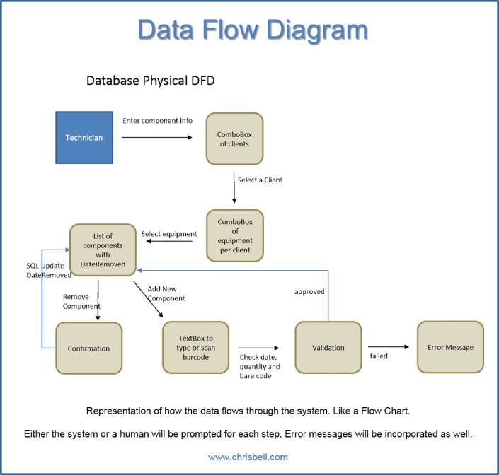

6.PROJECT PLANNING AND SCHEDULING

6.1 TECHNICAL ARCHITECTURE

Creating innovative product ideas requires an effective, unobtrusive approach to managing conceptual design data. Because conceptual design is a fast-paced, constantlychanging process, during which designers utilize trial-and-error approaches and “what if” scenarios to gain the understanding that leads to innovation, it requires a transparent data management solution. Instead of thinking about or anticipating what data needs to be saved and managed—like when using existing data management tools that focus on the later phases of product development and production—designers working on concept development must be free to investigate multiple approaches, evolve innovative ideas, and explore various concepts, with all data capture and management taking place in the background. By automatically and transparently performing all data management operations in the cloud, the SolidWorks® Mechanical Conceptual solution liberates designers from traditional data management distractions, while simultaneously capturing, saving, and managing all conceptual design activity—including concept ideas, conversations, and design reviews—for future use, development, or adaptation

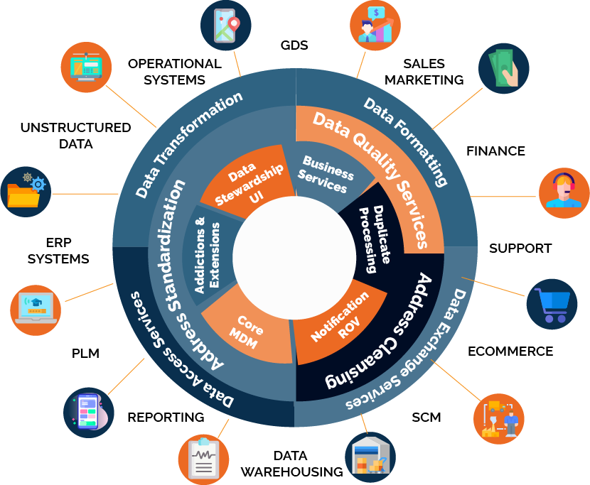

6.2 SPIRINT PLANNING & ESTIMATION

Sprint planning is a key activity in Agile project management, specifically within Scrum methodology. It involves a team coming together to plan and agree on the work they will complete during an upcoming sprint. A sprint is a fixed time period, typically 2-4 weeks, in which a set of features, user stories, or tasks are developed and delivered.

Backlog Transparency:

The product backlog, which is a list of tasks or user stories, should be transparent and prioritized. The team should understand what needs to be done and the relative importance of each item.

Capacity Transparency:

Team members need to be aware of their capacity to work on tasks during the sprint. This ensures that they commit to a realistic amount of work.

**Estimation:**

Estimation is a part of sprint planning where the team estimates the effort required to complete the selected tasks. Transparent toll-free data management could relate to estimation in the following ways:

Data-Driven Estimation:

Utilize transparent access to historical data related to task completion times, team velocity, and past performance to make more accurate estimations. Transparency in data access ensures that estimation is based on real historical metrics.

No Hidden Costs:

In the context of sprint planning, transparency ensures that the estimated effort includes all the work required, so there are no hidden costs or unexpected issues that arise during the sprint.

Backlog Refinement:

Reviewing and refining the product backlog, which is a prioritized list of tasks or user stories.

Setting Sprint Goals:

Defining the goals and objectives for the sprint.

Selecting Work:

The team selects a subset of items from the product backlog to work on during the sprint, based on priority and capacity.

Commitment:

The team commits to delivering the selected work by the end of the sprint.

6.3 SPRINT DELIVERY SCHEDULE

Transparent toll-free data management" in the context of "sprint delivery schedule" suggests a desire for clarity and openness in managing data, particularly in relation to scheduling and delivering project sprints. Here's how these concepts can be connected.

Sprint Delivery Schedule:

In Agile project management, a sprint is a time-boxed period during which a specific set of work is completed. Sprint delivery schedule refers to the plan for when and how the work within a sprint will be delivered. This schedule typically includes milestones and release dates for completed features or increments.

Transparent Toll-Free Data Management in Sprint Delivery:

Clear Data Access:

Transparent toll-free data management implies that data related to the project, such as progress, sprint metrics, and resource utilization, should be easily accessible to team members and stakeholders. This transparency can help in tracking the sprint's progress and making informed decisions.

Cost Clarity:

When managing data, it's important to ensure that there are no hidden costs associated with data usage. A transparent approach means that there are no unexpected charges or fees related to data management during the sprint.

Resource Allocation:

Transparent data management can provide insights into how resources (e.g., servers, databases, cloud services) are allocated and utilized during the sprint. This information is essential for effective sprint delivery planning.

Integration:

To connect transparent toll-free data management with sprint delivery scheduling, it's crucial to have a system or process in place that offers visibility into data usage, costs, and resource allocation. This information can inform decisions about when and how sprint deliverables are released.

Having a transparent approach to data management can reduce the risk of unforeseen obstacles and costs that might affect the sprint's delivery schedule. It can also lead to more accurate planning and better coordination between teams and stakeholders.

In summary, integrating transparent toll-free data management practices into your sprint delivery schedule ensures that data-related processes are clear, accessible, and free from hidden costs, which, in turn, can contribute to more predictable and successful sprint deliveries.

Predictability:

Sprint scheduling helps to create a predictable and regular rhythm for software development. Sprints are time-boxed and have a clear start and end date, which allows the team to plan and estimate their work more effectively.

Flexibility:

Sprint scheduling allows for flexibility and adaptability in the development process. Agile methodologies emphasize responding to change, and sprints provide a framework for making adjustments based on feedback and new requirements.

Transparency:

Sprint scheduling provides transparency into the progress of the project. Each sprint results in a potentially shippable increment of the software, which allows stakeholders to see tangible progress and provide feedback.

Collaboration:

Sprint scheduling encourages collaboration and communication between the development team, product owner, and other stakeholders. Sprint planning meetings, daily stand-up meetings, and sprint reviews provide opportunities for the team to work together and stay aligned.

Prioritization:

Sprint scheduling helps to prioritize and manage the backlog of features and user stories. The product owner and development team can work together to select the highest-priority items for each sprint, which ensures that the most valuable work is being completed first.

Be firm about sprint deadlines:

Challenges are bound to arise during sprints that can make it difficult or impossible to meet deadlines. But as a project manager, it’s your job to ensure projects remain on track no matter what. Part of managing sprints involves knowing when to be firm about deadlines and when to extend time frames to accommodate sudden changes or unexpected issues. Keep in mind that if you consistently break deadlines, it can impact the time frame of an agile project, setting a launch back weeks or even months beyond its target date.

Have developers sign off on sprint goals:

Developers are usually busy and simultaneously balance multiple projects. While it’s easy to rush through sprint planning and scheduling and take on too much work, doing so leads to missed deadlines, finger-pointing, rushed work, and project delays. To prevent this from happening, it helps to have deep visibility into what other people are working on. It also helps to have developers sign off on sprint goals to vouch that they agree to each sprint workload and can meet their target objectives.

Leave a gap between sprints:

It can help to leave a gap of one or two days between next sprint and previous sprint. This helps control the pace of development and provides opportunities for assessing progress and making changes. Leaving a gap can also help reduce burnout and give developers a chance to recharge between coding sessions.

Avoid changing sprint goals:

It can be tempting to change sprint goals as new stories enter into the mix and priorities change. But in general, it’s best to avoid changing sprint goals once you finalize your schedule. If you start changing them consistently, you can lose sight of the overall objective. To avoid complications, it helps to have a system in place for prioritizing new additions and adding steps into the process. Sticking with a plan results in an organized system that is efficient for everyone involved.

Employ Release Management Tooling:

Sprint scheduling and planning is a time-consuming process. Team leaders spend hours planning schedules and incorporating changes. To streamline communication and make it easier to assess resources needed for upcoming sprints, many agile leaders use tools. These tools help teams quickly and efficiently plan their releases and sprints.

7.CODING & SCHEDULING

/ SPDX-License-Identifier: MIT

pragma solidity ^0.8.0;

contract TollFreeNumberRegistry {

struct TollFreeNumber {

address owner;

string phoneNumber;

string serviceProvider;

uint256 monthlyFee;

}

mapping(uint256 => TollFreeNumber) public tollFreeNumbers;

uint256 public numberCount;

event TollFreeNumberAdded(uint256 numberId, address owner, string phoneNumber, string serviceProvider, uint256 monthlyFee);

event TollFreeNumberUpdated(uint256 numberId, string phoneNumber, string serviceProvider, uint256 monthlyFee);

modifier onlyOwner(uint256 _numberId) {

require(tollFreeNumbers[_numberId].owner == msg.sender, "Only the owner can perform this action");

_;

}

function addTollFreeNumber(string memory _phoneNumber, string memory _serviceProvider, uint256 _monthlyFee) external {

numberCount++;

tollFreeNumbers[numberCount] = TollFreeNumber(msg.sender, _phoneNumber, _serviceProvider, _monthlyFee);

emit TollFreeNumberAdded(numberCount, msg.sender, _phoneNumber, _serviceProvider, _monthlyFee);

}

function updateTollFreeNumber(uint256 _numberId, string memory _phoneNumber, string memory _serviceProvider, uint256 _monthlyFee) external onlyOwner(_numberId) {

TollFreeNumber storage tollFreeNumber = tollFreeNumbers[_numberId];

tollFreeNumber.phoneNumber = _phoneNumber;

tollFreeNumber.serviceProvider = _serviceProvider;

tollFreeNumber.monthlyFee = _monthlyFee;

emit TollFreeNumberUpdated(_numberId, _phoneNumber, _serviceProvider, _monthlyFee);

}

function getTollFreeNumberDetails(uint256 _numberId) external view returns (address owner, string memory phoneNumber, string memory serviceProvider, uint256 monthlyFee) {

TollFreeNumber memory tollFreeNumber = tollFreeNumbers[_numberId];

return (tollFreeNumber.owner, tollFreeNumber.phoneNumber, tollFreeNumber.serviceProvider, tollFreeNumber.monthlyFee);

}

}

8.PERFORMANCE TESTING

Data security is being one of the most crucial aspects to be focused on system development. However, using such a feature to enhance the security of data might affect the system's performance. This study aims to observe how substantial Transparent Data Encryption as a solution for data security on Microsoft SQL Server will affect the database management system's performance. Each of the system performance is conducted with stress and load test. This paper concentrates on the upsides of using Transparent Data Encryption over standard database by finding how significant performance degradation has occurred in terms of Reliability and Efficiency.

9.RESULTS

9.1 OUTPUT SCREENSHOTS

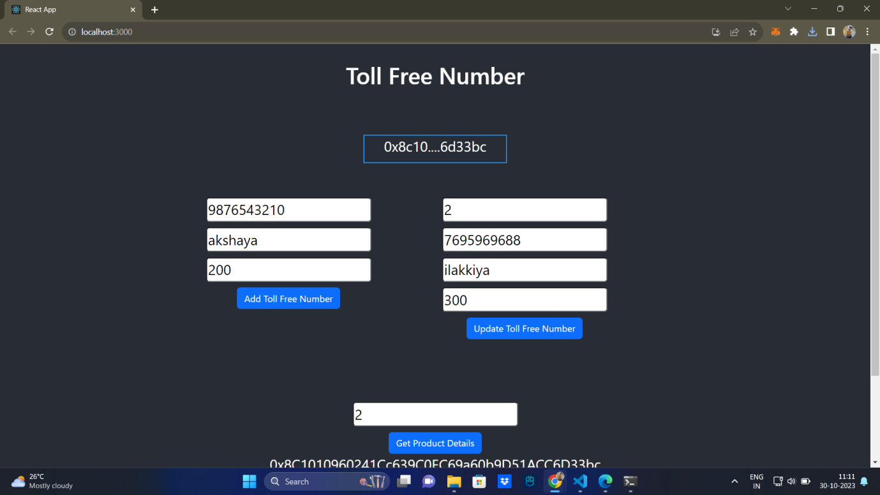

10.ADVANTAGES & DISADVANTAGES

ADVANTAGES

Transparent toll-free data management offers several advantages, primarily in the context of telecommunications and data services. Here are some key benefits of implementing transparent data management:

Cost Clarity:

One of the most significant advantages is cost transparency. Users have a clear understanding of the costs associated with data usage. This transparency helps individuals and businesses manage their expenses effectively and avoid unexpected charges or overage fees.

Improved Budgeting:

Transparent data management allows for better budgeting and financial planning. Users can accurately predict their data-related expenses, which is especially crucial for businesses with tight budgets.

Customer Trust:

Service providers that offer transparent data management build trust with their customers. When users can easily understand and monitor their data usage, they are more likely to have confidence in the service provider.

Fair Usage Policies:

Many data plans have fair usage policies to prevent abuse. Transparent data management allows users to see if they are approaching these limits, which can help them avoid throttling or other consequences.

Data Efficiency:

Users can make more informed decisions about data usage. They may adjust their behavior or opt for different plans based on their actual data consumption, leading to more efficient use of resources.

Billing Disputes Resolution:

Transparency in data management helps in quickly resolving billing disputes. Users can reference their data usage and compare it to their bills, which streamlines dispute resolution processes.

Customization:

Users can choose data plans that best suit their needs because they have a clear understanding of their usage patterns. This customization can lead to more cost-effective plans and improved user satisfaction.

Data Optimization:

Service providers can offer tools and recommendations to help users optimize their data usage. This can result in better network efficiency and user experience.

Compliance and Regulations:

In some regions, there are regulations in place to ensure transparency in data billing and management. Complying with these regulations is essential for service providers, and it helps protect consumer rights.

Competitive Advantage:

Offering transparent data management can be a competitive advantage in the telecommunications market. Customers are more likely to choose service providers who provide clear and fair data management practices.

Customer Education:

Transparent data management encourages customer education about data usage and how to make the most of their plans. Educated customers are more likely to be satisfied and loyal.

DISADVANTAGES

Complexity:

Implementing transparent data management systems and processes can be complex and costly. It may require significant investments in infrastructure, monitoring tools, and staff training.

Data Privacy Concerns:

Transparent data management often involves collecting and monitoring user data. This can raise privacy concerns, especially if users are uncomfortable with the level of data scrutiny required for transparency.

Data Security Risks:

Storing and managing large amounts of data for transparency purposes can be a security risk. This data may be vulnerable to breaches, putting sensitive information at risk.

Resource Overhead:

Managing transparency in data usage requires additional resources, both in terms of hardware and personnel. This can increase operating costs for service providers, which may be passed on to consumers.

Data Manipulation:

In some cases, service providers may manipulate data management practices to their advantage, making it appear more transparent than it actually is. This can lead to mistrust among users.

Overly Complex Plans:

In an effort to provide transparency, service providers may create overly complex data plans and pricing structures, which can confuse and frustrate users.

User Confusion:

Despite the intention of transparency, some users may find it difficult to interpret and make use of the data management information provided to them, leading to confusion and dissatisfaction.

Regulatory Compliance Challenges:

Adhering to regulations regarding data management transparency can be a significant challenge for service providers. Non-compliance can result in legal issues and fines.

Loss of Revenue:

Transparent data management may result in service providers losing revenue from overage charges and hidden fees, which are no longer part of their revenue stream.

Network Congestion:

In some cases, users may take advantage of transparent data management to maximize their data usage, potentially leading to network congestion and degraded service quality for other users.

Limited Plan Options:

Some service providers may reduce the variety of data plans available to simplify transparency, limiting user choices and potentially making it challenging for users to find a plan that suits their needs.

11.CONCLUSION

Transparent toll-free data management offers numerous benefits, such as cost clarity, improved budgeting, customer trust, and fair usage policies. It empowers users to make informed decisions about their data usage and helps resolve billing disputes efficiently. Service providers who offer transparent data management can gain a competitive advantage and foster customer loyalty.

However, it's essential to acknowledge the potential disadvantages, including complexity, data privacy concerns, security risks, resource overhead, and the risk of data manipulation. Service providers must navigate these challenges while implementing transparent data management systems effectively. In conclusion, transparent toll-free data management can contribute to fairness and trust in telecommunications and data services, enhancing the user experience. However, it requires careful planning and consideration of potential drawbacks to ensure a successful and beneficial implementation. It's a balance between providing transparency and addressing the complexities and concerns that may arise in the process.

12.FUTURE SCOPE

* The future scope of transparent toll-free data management is promising and continues to evolve with advancements in technology, changing consumer expectations, and regulatory developments. Here are some aspects of its future scope:
* Advanced Analytics and AI
* 5G and IoT
* Blockchain and Data Security
* Privacy Protection
* Customized Plans
* Regulatory Compliance
* Smart Devices and Integration
* Cost Efficiency
* Sustainability
* International Roaming
* Data Sharing
* User Education

APPLICATIONS

* Telecommunications and Mobile Services
* Internet Service Providers (ISPs)
* IoT and Smart Devices
* Cloud Services
* Enterprise and Business
* Government and Public Services
* Travel and Hospitality
* Automated Services